Practical 5:
Registration Form with Frontend Validation and User-Friendly Error Handling
Problem Definition:
Create a student registration form with HTML5 input types and JavaScript validation for name, email, mobile number, password, confirm password,course, year, gender, and terms acceptance. Use Regular Expression for validations.
Theory :
1. Are correct input types and attributes used? Yes, correct input types like text, email, and tel are used. The required attribute makes fields compulsory.
2. Are validation errors displayed near the relevant fields? Yes, error messages should appear near the fields where mistakes occur.
3. Is password strength checked? Yes, if the form has a password field, its length and strength should be checked.
4. Is the form accessible using a keyboard and screen-reader-friendly labels? Yes, labels should be clear, and users should be able to use the form with a keyboard
Implementation/out put/result:

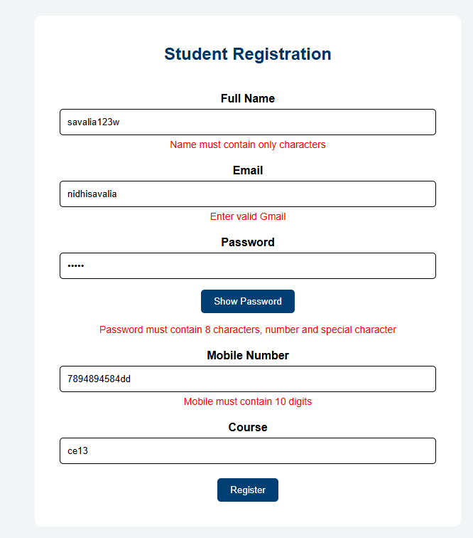
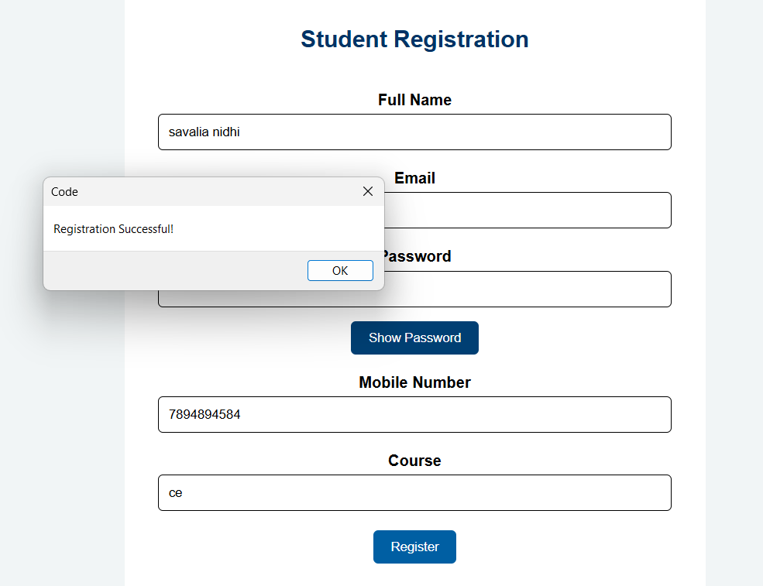
Git hub link:
https://github.com/nidhisavalia/25dce103-web

Faculty remarks:

